|  |  |
| --- | --- |
| Q1 | How to specify DTD version of HTML5 |
|  | a) <!DOCTYPE html> b) <!HTML5> c) <DOCTYPE html> d) None of the above |

|  |  |
| --- | --- |
| Q2 | Header section in Html5 |
|  | a) h1 b) head c) header d) section |

|  |  |
| --- | --- |
| Q3 | How to provide comments in html page |
|  | a) //single line comment b) /* multi line comments */ c) Both a & b d) <! -- comment -- > |

|  |  |
| --- | --- |
| Q4 | Which of the following input control represents a date and time (including all parts like year, month, day, hour, minute, second, fractions of a second) encoded according to ISO 8601 with the time zone set to UTC in Web Form 2.0? |
|  | a) date b) datetime c) datetime-local d) time |

|  |  |
| --- | --- |
| Q5 | How to provide roman in list items at ol tag? a |
|  | a) <ol type="i"></ol> b) <ol type="r"> </ol> c) <ol type="roman"> </ol> d) All of the above |

|  |  |
| --- | --- |
| Q6 | How to group radio buttons into one category? |
|  | a) By providing common id b) By providing common name  c) By providing groupname d) all of the above |

|  |  |
| --- | --- |
| Q7 | How to provide ListBox in HTML |
|  | a) <select> </select> b) <select multiple> </select>  c) <listbox> </listbox> d) None of the above |

|  |  |
| --- | --- |
| Q8 | How to provide multiline textbox in html |
|  | a) <multiline> </multiline> b) <input type=text multiple>  c) <textarea> </textarea> d) All of the above |

|  |  |
| --- | --- |
| Q9 | How to import javascript file in html page? |
|  | a) <script src="filename.js"> </script> b) <link rel="script" href="filename.js" >  c) /// <reference path="filename.js" /> d) all of the above |

|  |  |
| --- | --- |
| Q10 | How to import css file in html page? |
|  | a) <script src="filename.js"> </script> b) <link rel="stylesheet" href="filename.css" >  c) /// <reference path="filename.js" /> d) all of the above |

|  |  |
| --- | --- |
| Q11 | The following property in input elemnt provides a hint to the user of what can be entered in the field in HTML5? |
|  | a) autofocus b) alert c) output d) required |

|  |  |
| --- | --- |
| Q12 | How to restrict empty input value before form submission? |
|  | a) mandate b) autocomplete c) required d) none of the above |

|  |  |
| --- | --- |
| Q13 | The following attribute triggers event when the window gets focus |
|  | a) focus b) onfocus c) onforminput d) All of the above |

|  |  |
| --- | --- |
| Q14 | The following attribute triggers events when the document has change? |
|  | a) onhaschange b) oninput c) onchange d) onloadeddata |

|  |  |
| --- | --- |
| Q15 | What is the true about session storage? |
|  | a) Gets erased only when the browser is closed, remain when the tab is closed  b) Gets erased when the tab is closed.  c) Will remain even browser is restarted d) None of the above |

|  |  |
| --- | --- |
| Q16 | Which of the following are correct about Geolocation API? |
|  | A - The geolocation APIs work with a new property of the global navigator object.  B - The geolocation object is a service object that allows widgets to retrieve information about the geographic location of the device.  C - getCurrentPosition() method retrieves the current geographic location of the user.  D - All of the above. |

|  |  |
| --- | --- |
| Q17 | HTML5 provide following features under Multi media |
|  | a) <video> and <audio> elements b) <multimedia> element  c) Both of the above d) None of the above |

|  |  |
| --- | --- |
| Q18 | What is the use of Canvas? |
|  | a) Used to draw graphics with html element with properties  b) Used to draw graphics using Javascript with properties  c) Both a & b d) None of the above |

|  |  |
| --- | --- |
| Q19 | How to implement threads in HTML5 |
|  | a) Using Thread b) Using WebWorkers c) Using Ajax d) None of the above |

|  |  |
| --- | --- |
| Q20 | What is the true above SVG? |
|  | a) Used to draw graphics with html element with properties  b) Used to draw graphics using Javascript with properties  c) Both a & b d) None of the above |

**Task:**

1) Create Login Page

restrict page submission when uname and pwd is empty

redirect to success page if input is not empty

2) design the following UI

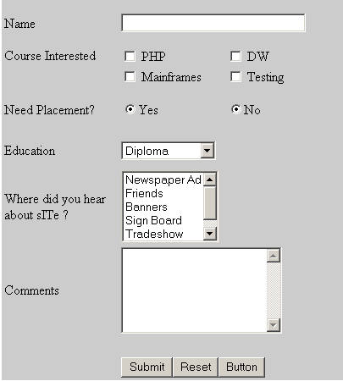

0033) Display current location map using geolocation feature

4) Task on Local Storage:

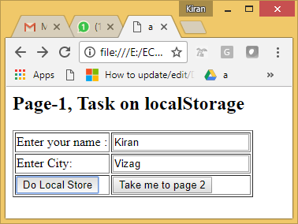 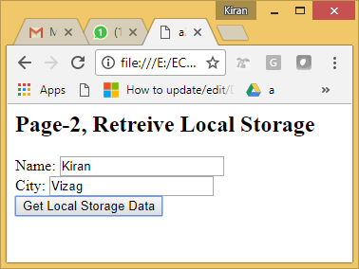

Design Page1.html with the following

Input name and city textboxes and submit button

When the submit button click, the input to be displayed in the second page

5) Design the following table

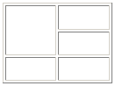

|  |  |
| --- | --- |
|  | **Reference links:** |
|  | https://www.w3schools.com/tags/default.asp |
|  | http://www.tutorialspoint.com/html/ |

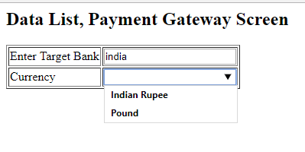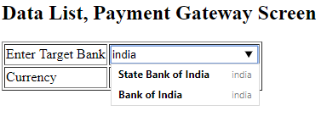

|  |  |  |  |
| --- | --- | --- | --- |
| **Sl.No** | **Correct Option** | **Sl.No** | **Correct Option** |
| 1 | a | 11 | D |
| 2 | b | 12 | C |
| 3 | d | 13 | B |
| 4 | b | 14 | A |
| 5 | a | 15 | B |
| 6 | b | 16 | D |
| 7 | b | 17 | A |
| 8 | c | 18 | B |
| 9 | a | 19 | B |
| 10 | b | 20 | A |

|  |  |
| --- | --- |
| 4 | **Local storage and global storage source** |
| Page1.html | <script>  Store=function(){  var name = document.getElementById("name").value;  var city = document.getElementById("city").value;  localStorage.setItem("name",name);  localStorage.setItem("city",city);  }  </script>  <h2>Page-1, Task on localStorage</h2>  <form action="a2.html">  <table border="1">  <tr>  <td>Enter your name :</td>  <td><input type="text" id="name"></td>  </tr>  <tr>  <td>Enter City:</td>  <td><input type="text" id="city"></td>  </tr>  <tr>  <td><button onclick='Store()'>Do Local Store</button></td>  <td><button onclick='this.form.submit()'>Take me to page 2</button></td>  </tr>  </table>  </form> |
| Page2.html | <script>  Retrieve=function(){  var name = localStorage.getItem("name");  var city = localStorage.getItem("city");  document.getElementById("name").value=name;  document.getElementById("city").value=city;  }  </script>  <h2>Page-2, Retreive Local Storage </h2>  Name: <input type="text" id="name"><br>  City: <input type="text" id="city"><br>  <button onclick="Retrieve()">Get Local Storage Data</button> |

|  |  |
| --- | --- |
| 5 | DataList |
|  | <h2>Data List, Payment Gateway Screen</h2>  <table border="1">  <tr>  <td>Enter Target Bank</td>  <td><input type="text" list="banks"></td>  </tr>  <tr>  <td>Currency</td>  <td><input type="text" list="currencies"></td>  </tr>  </table>  <datalist id="banks">  <option label="india" value="State Bank of India"></option>  <option label="india" value="Bank of India" />  </datalist>  <datalist id="currencies" >  <option value="Dollar">Dollar</option>  <option value="Indian Rupee">Indian Rupee</option>  <option value="Pound">Pound</option>    </datalist> |